## Round 1 – ‘Kid’ mode

**Q#1:**

SELECT DISTINCT JOB FROM EMP;

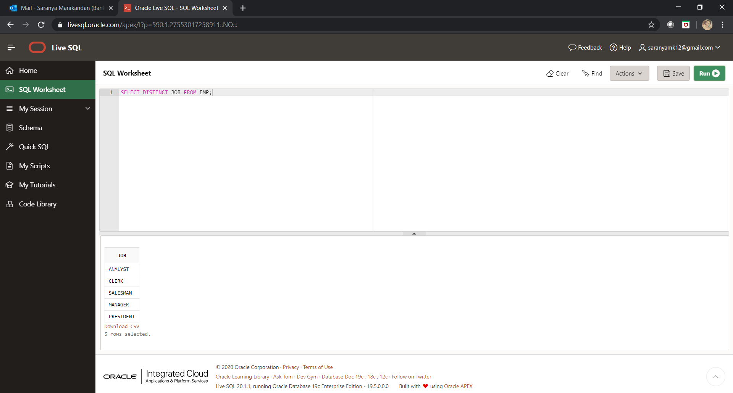

**Q#2:**

SELECT * FROM EMP ORDER BY SAL ASC;

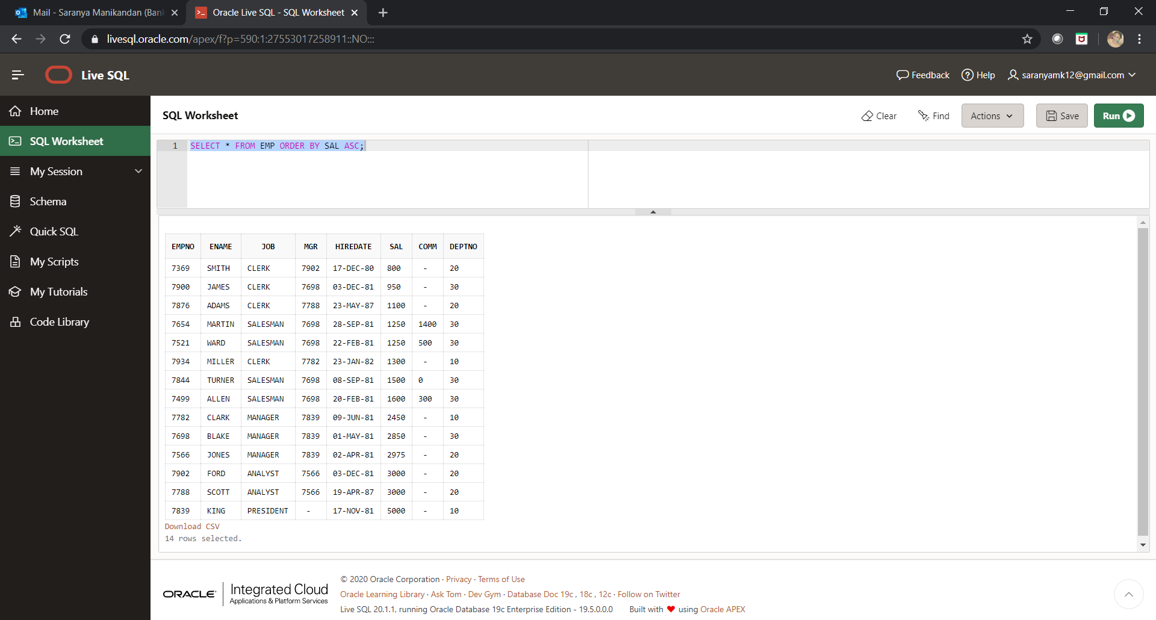

**Q#3:**

SELECT * FROM EMP ORDER BY DEPTNO ASC,JOB DESC;

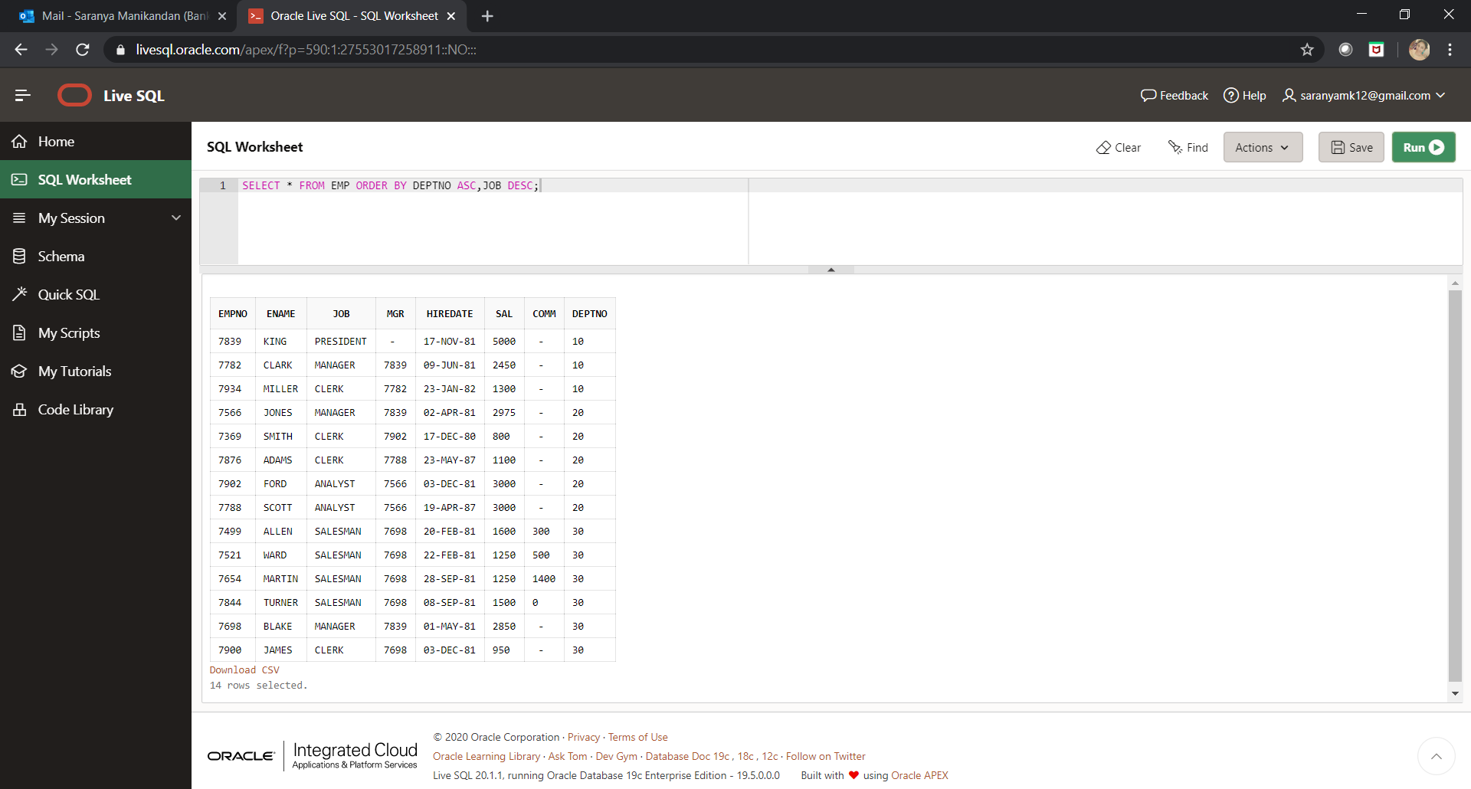

**Q#4:**

SELECT DISTINCT JOB FROM EMP ORDER BY JOB DESC;

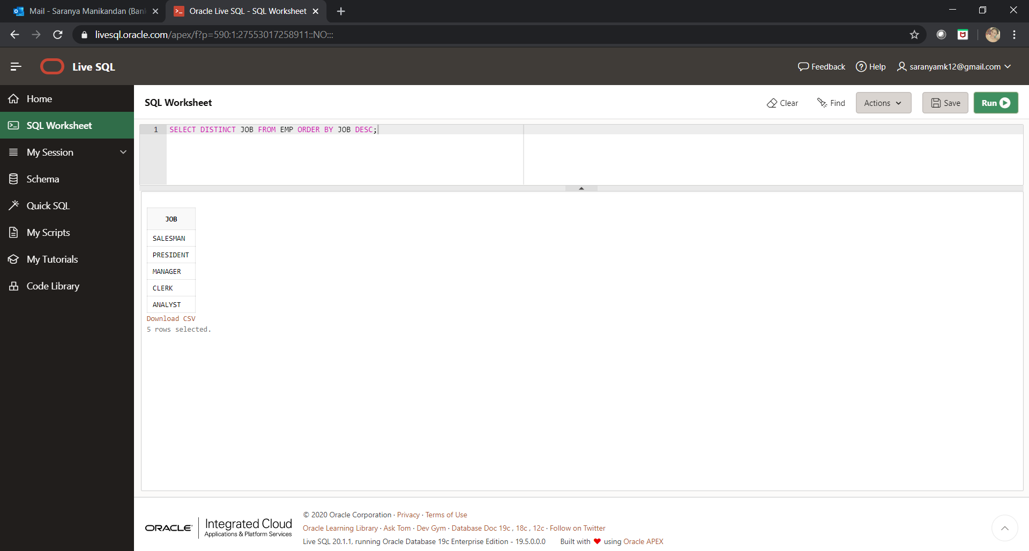

**Q#5:**

SELECT * FROM EMP WHERE JOB = 'MANAGER';

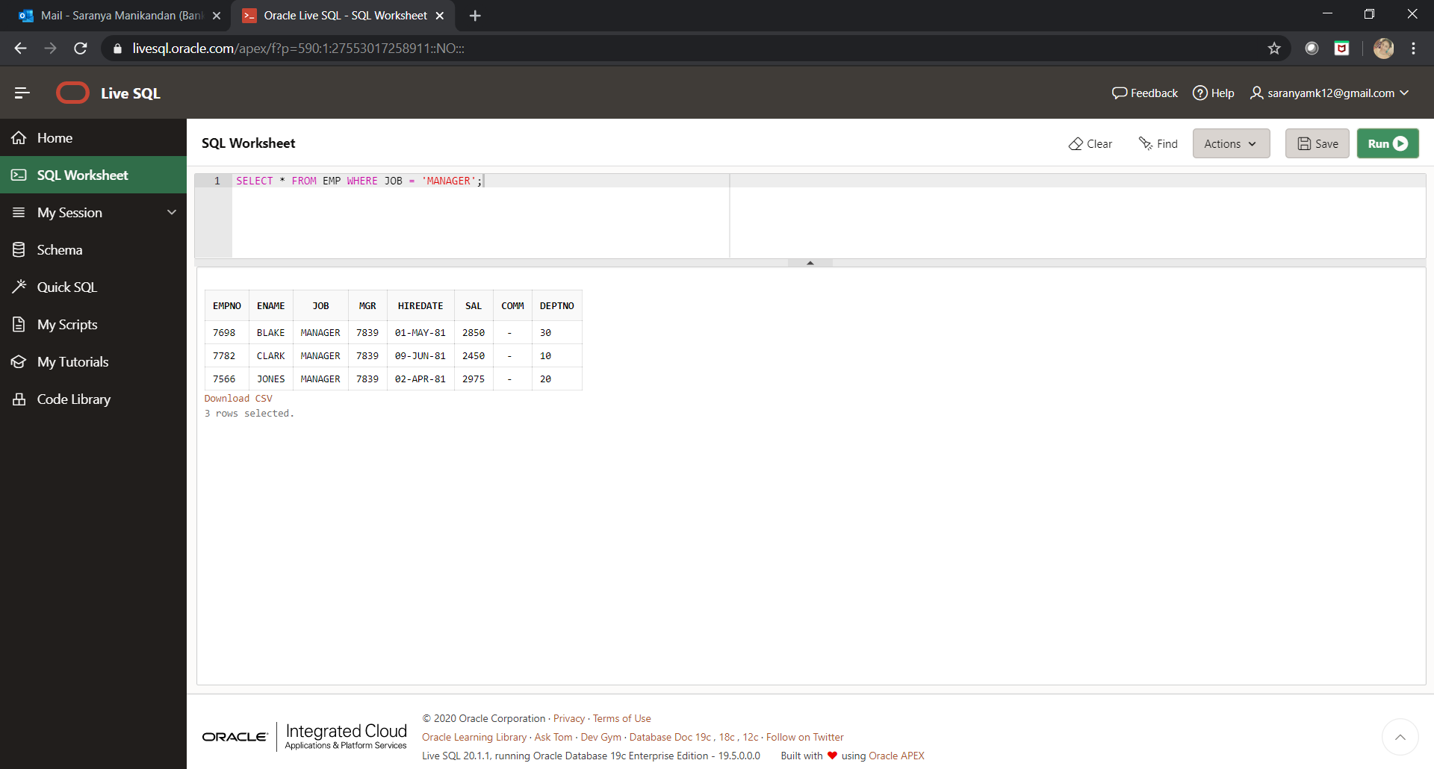

**Q#6:**

SELECT * FROM EMP WHERE HIREDATE < ('1-JAN-1981');

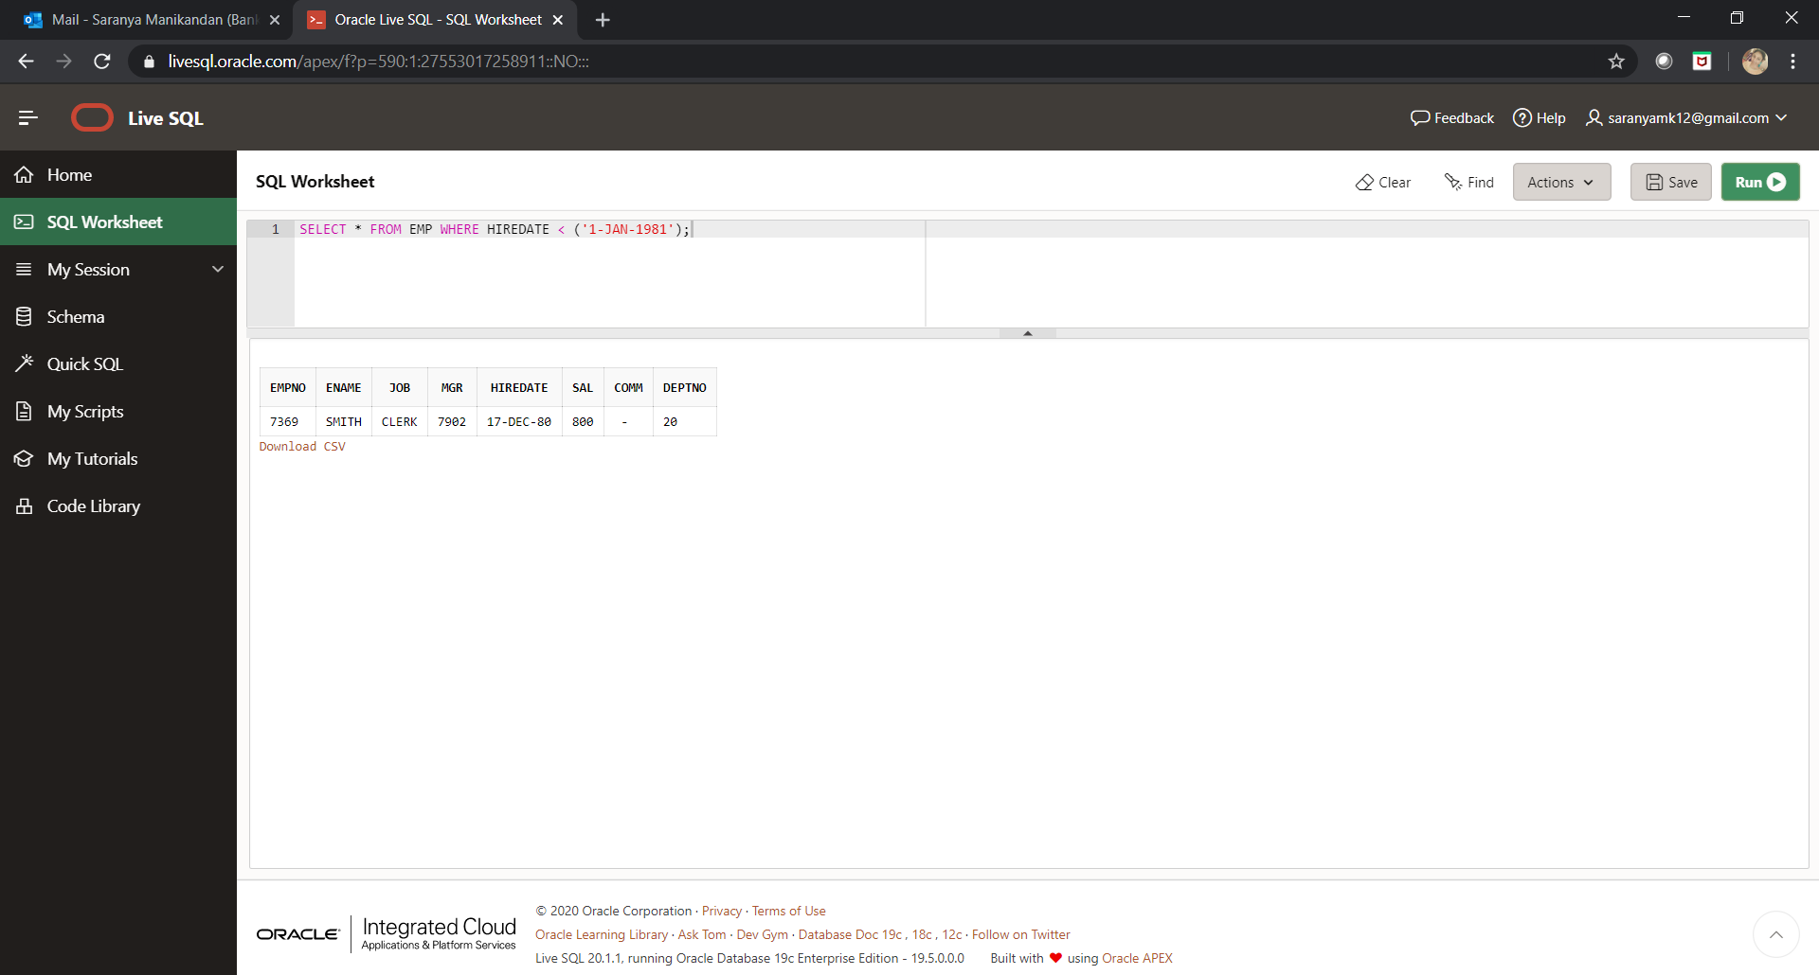

**Q#7:**

SELECT EMPNO,ENAME,SAL,SAL/30 AS DAILY,SAL*12 AS ANNUAL_SALARY FROM EMP ORDER BY ANNUAL_SALARY ASC;

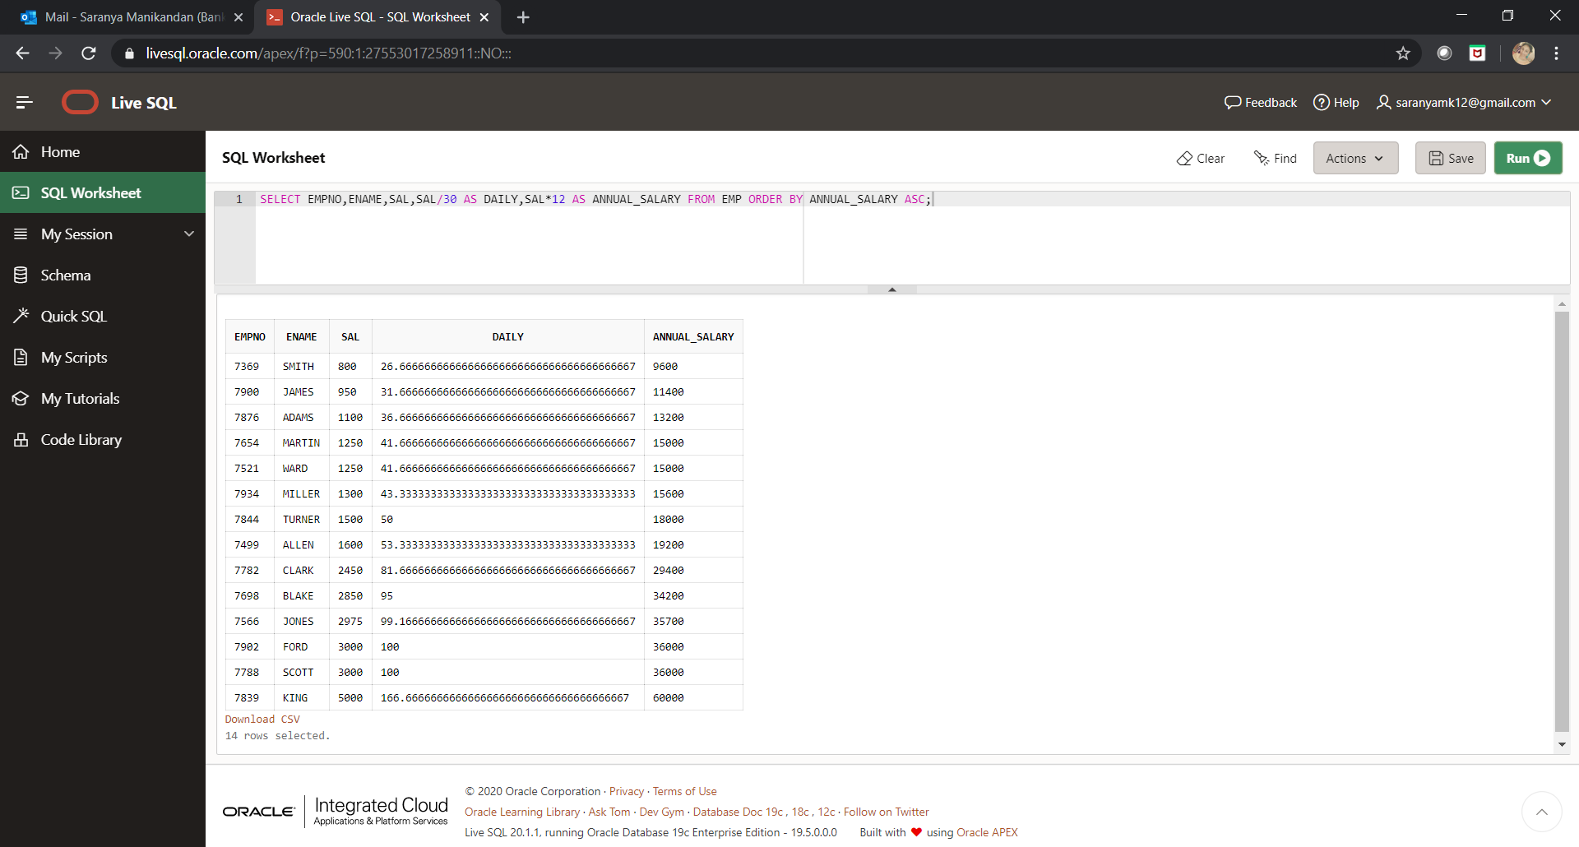

**Q#8:**

SELECT EMPNO,ENAME,JOB,HIREDATE,MONTHS_BETWEEN(SYSDATE,HIREDATE)/12 EXP FROM EMP WHERE JOB='MANAGER';

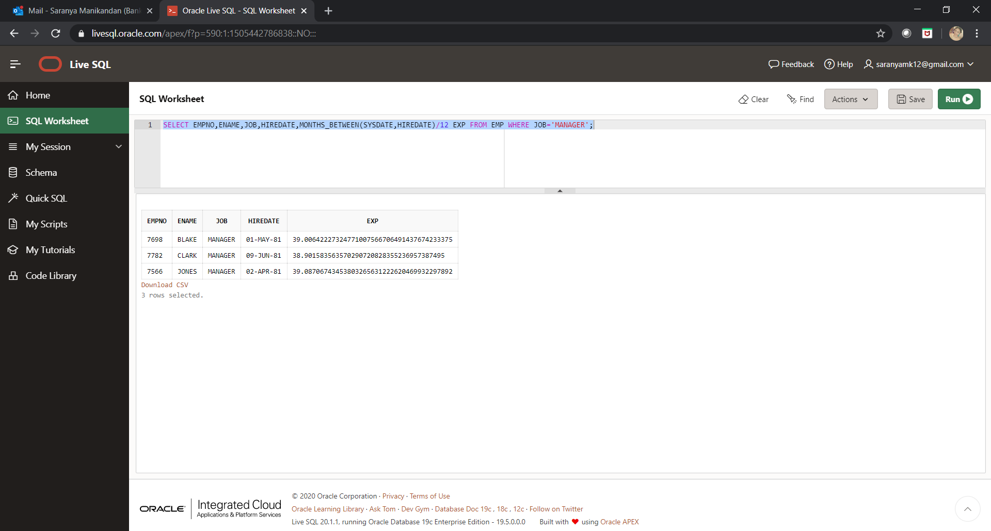

**Q#9:**

SELECT EMPNO,ENAME,SAL,MONTHS_BETWEEN(SYSDATE,HIREDATE)/12 EXP FROM EMP WHERE MGR='7369';

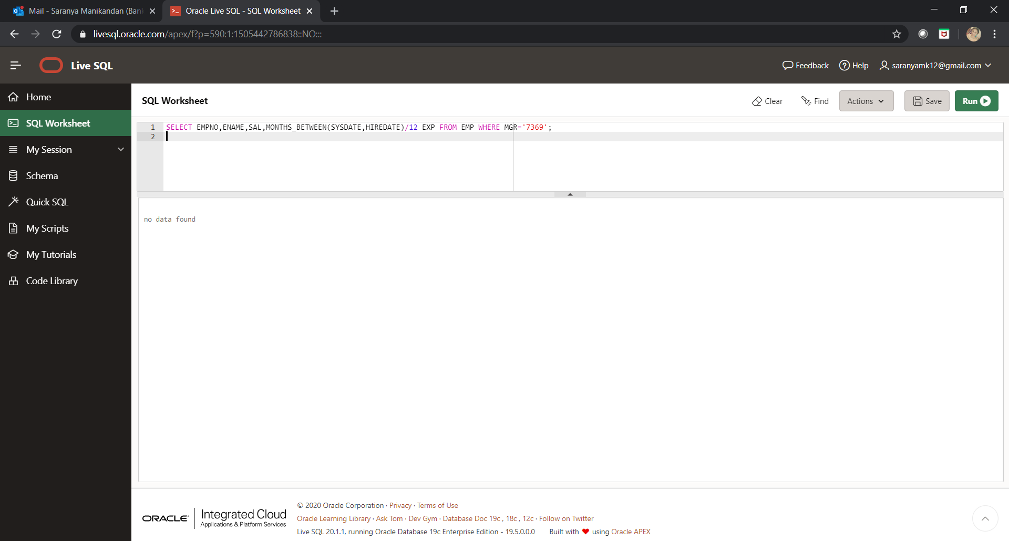

**Q#10:**

SELECT * FROM EMP WHERE COMM>SAL;

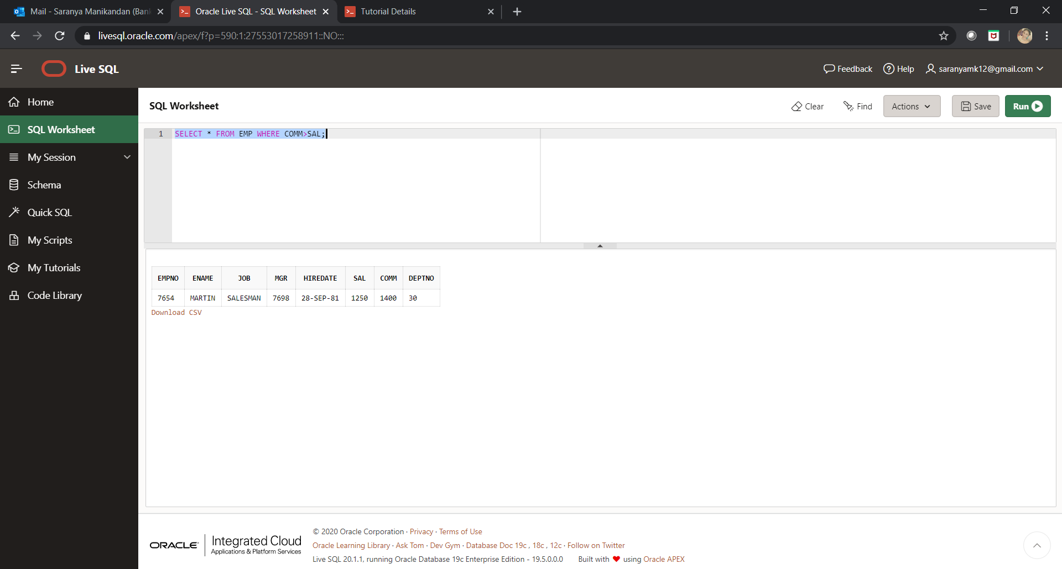

**Q#11:**

SELECT * FROM EMP WHERE HIREDATE > ('30-JUN-1981') ORDER BY JOB ASC;

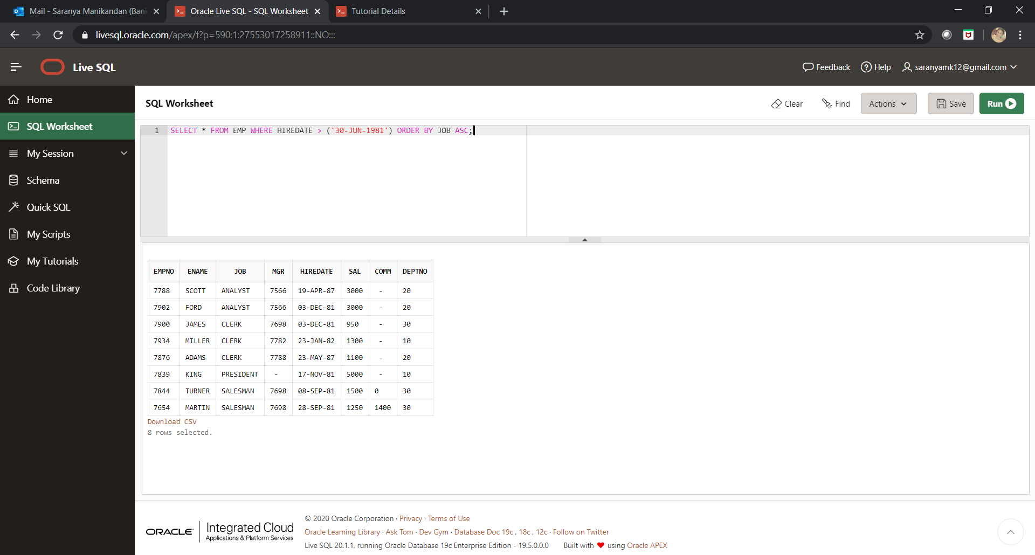

**Q#12:**

SELECT EMPNO,ENAME,JOB,MGR,HIREDATE,SAL,COMM,DEPTNO,MONTHS_BETWEEN(SYSDATE,HIREDATE)/12 EXP FROM EMP WHERE SAL/365 > 100;

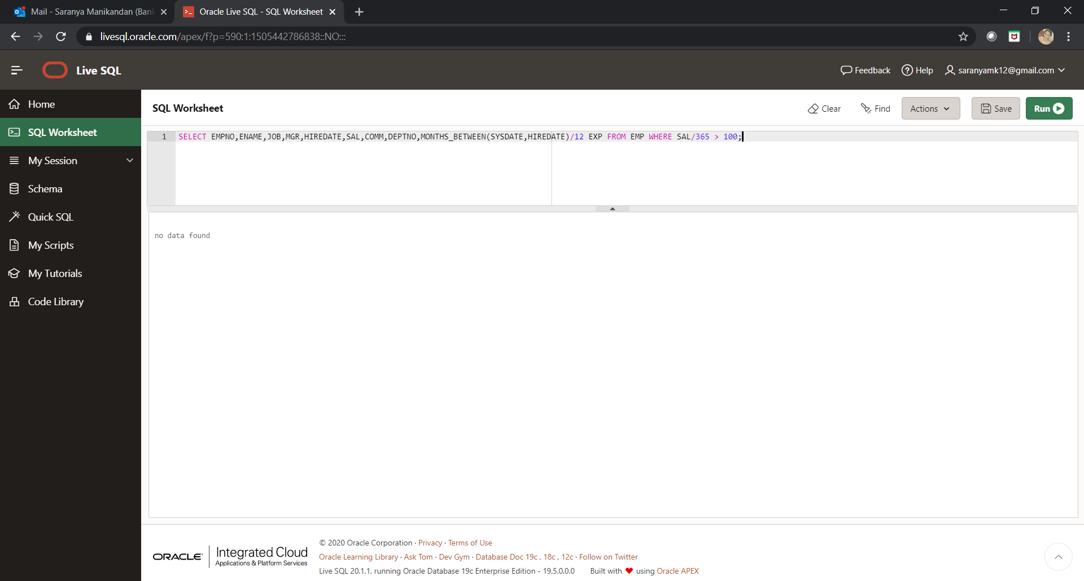

**Q#13:**

SELECT * FROM EMP WHERE JOB IN ('CLERK','ANALYST') ORDER BY JOB DESC;

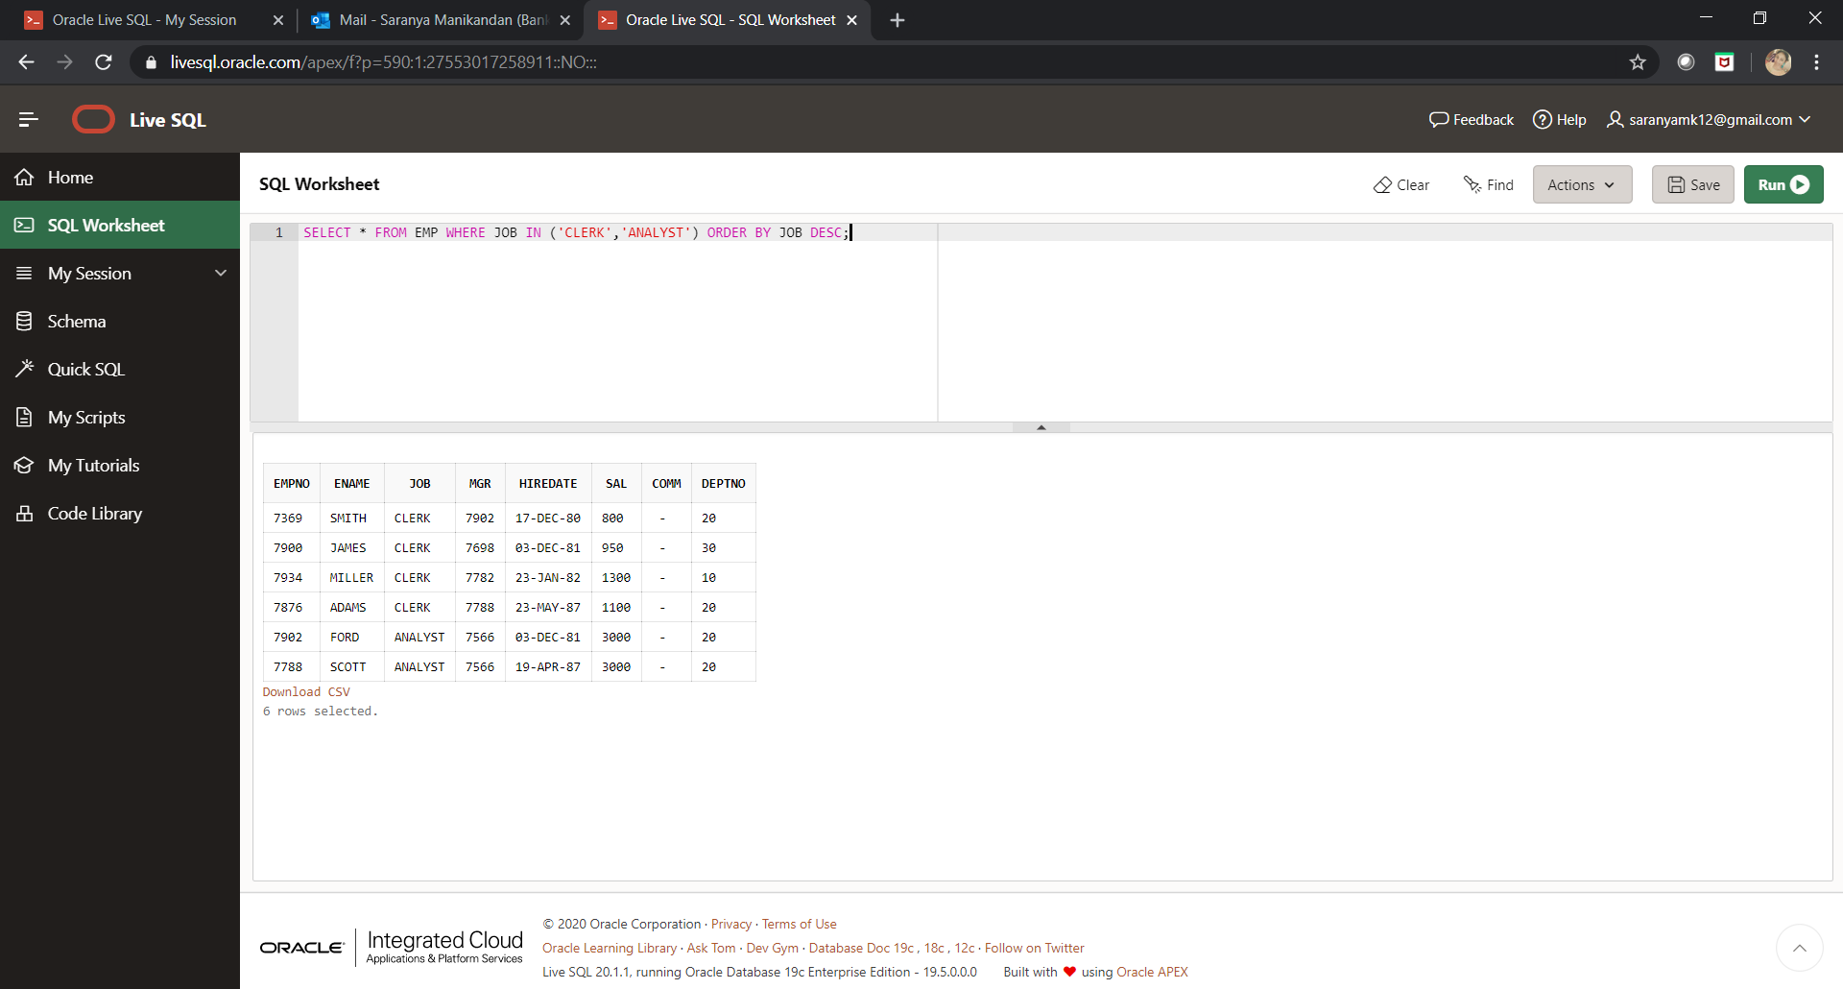

**Q#14:**

SELECT EMPNO,ENAME,JOB,MGR,HIREDATE,SAL,COMM,DEPTNO,MONTHS_BETWEEN(SYSDATE,HIREDATE)/12 EXP FROM EMP WHERE HIREDATE IN ('1-MAY-81','3-DEC-81','17-DEC-81','19-JAN-80') ORDER BY HIREDATE ASC;

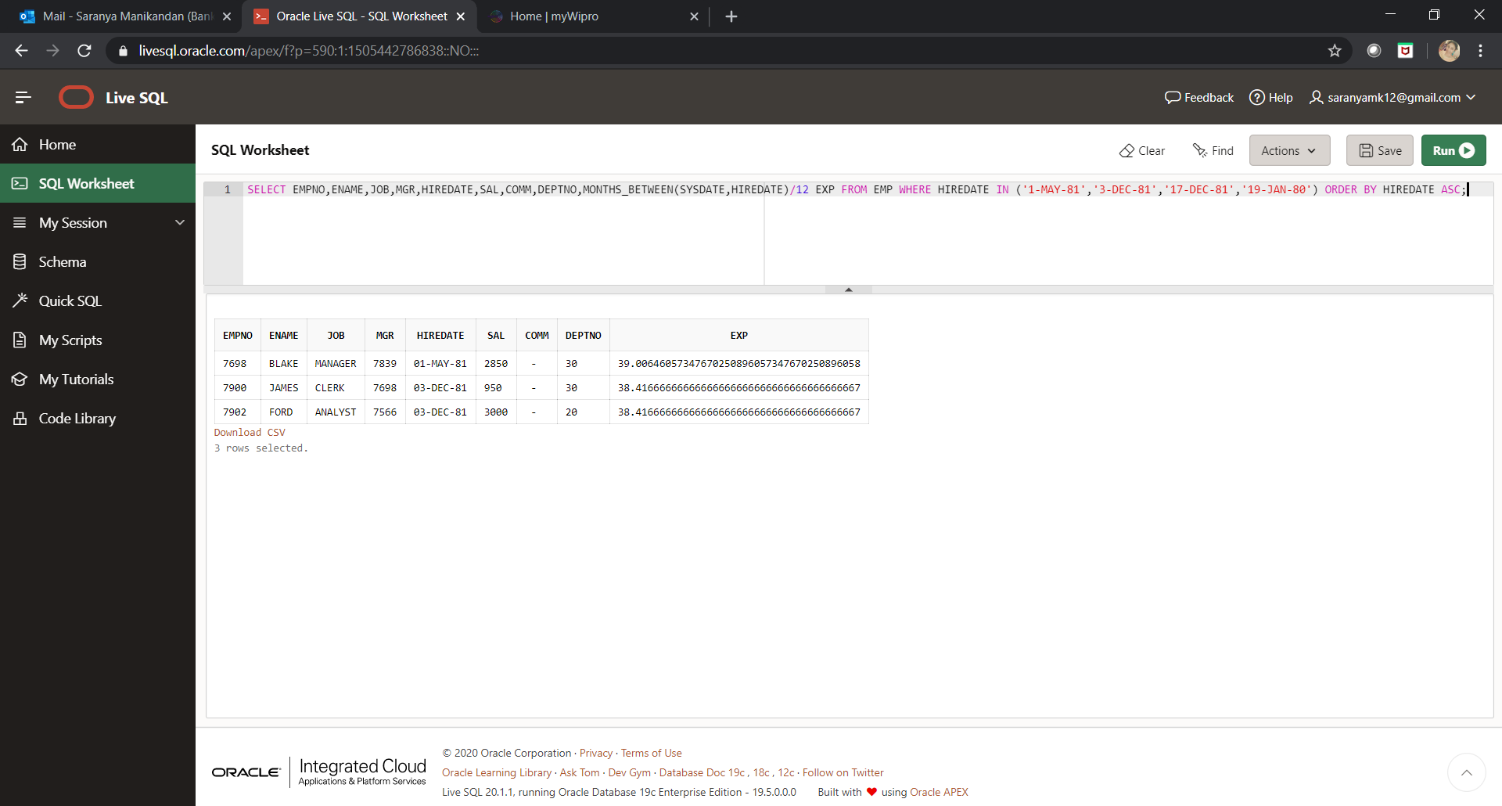

**Q#15:**

SELECT * FROM EMP WHERE DEPTNO IN ('10','20');

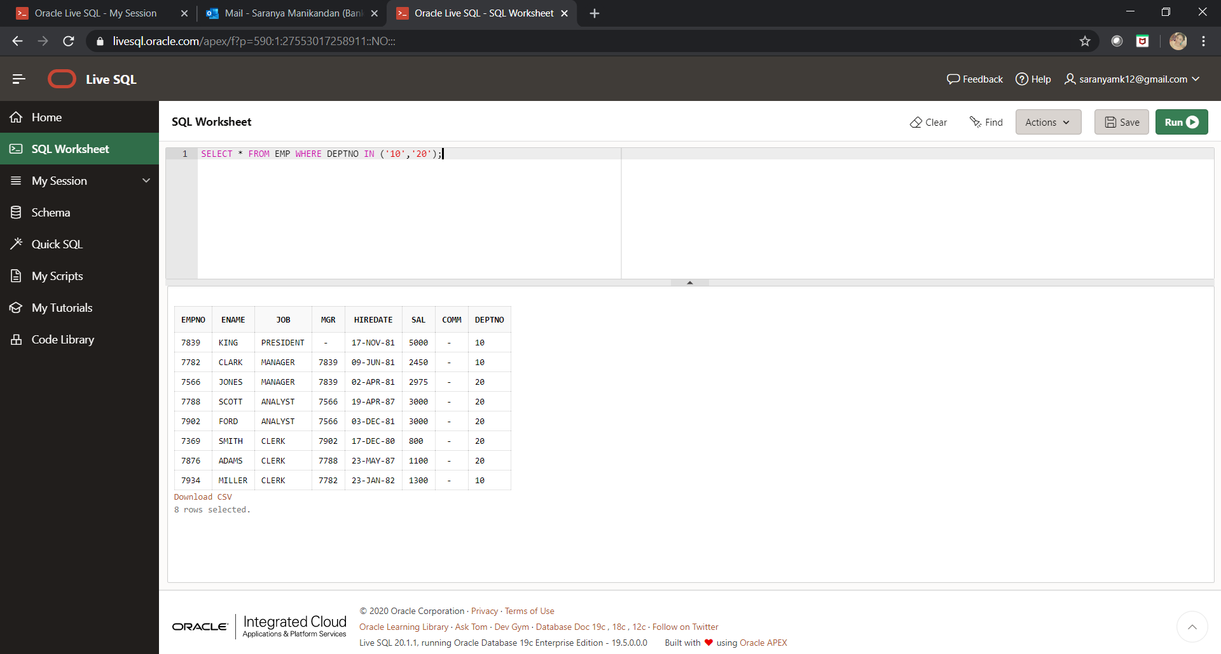

**Q#16:**

SELECT * FROM EMP WHERE HIREDATE BETWEEN '01-JAN-1981' AND '31-DEC-1981';

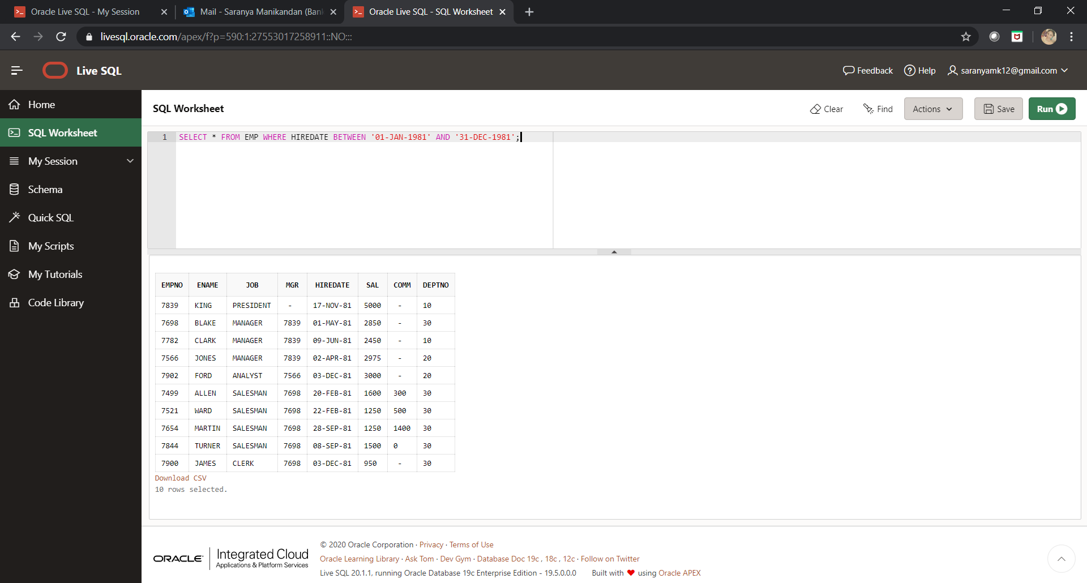

**Q#17:**

SELECT * FROM EMP WHERE HIREDATE BETWEEN '01-AUG-1980' AND '31-AUG-1980';

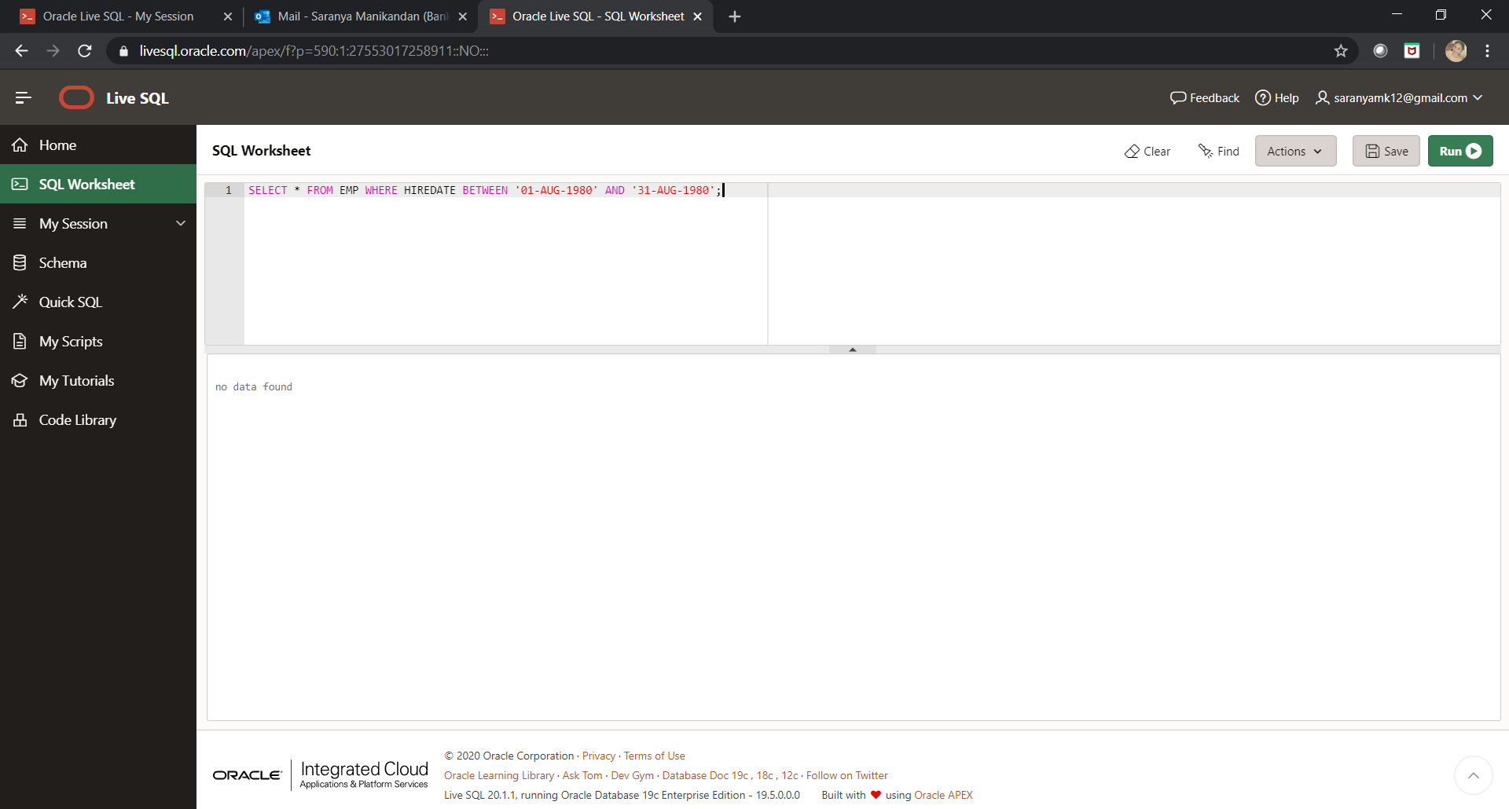

**Q#18:**

SELECT ENAME FROM EMP WHERE LENGTH(ENAME)=5;

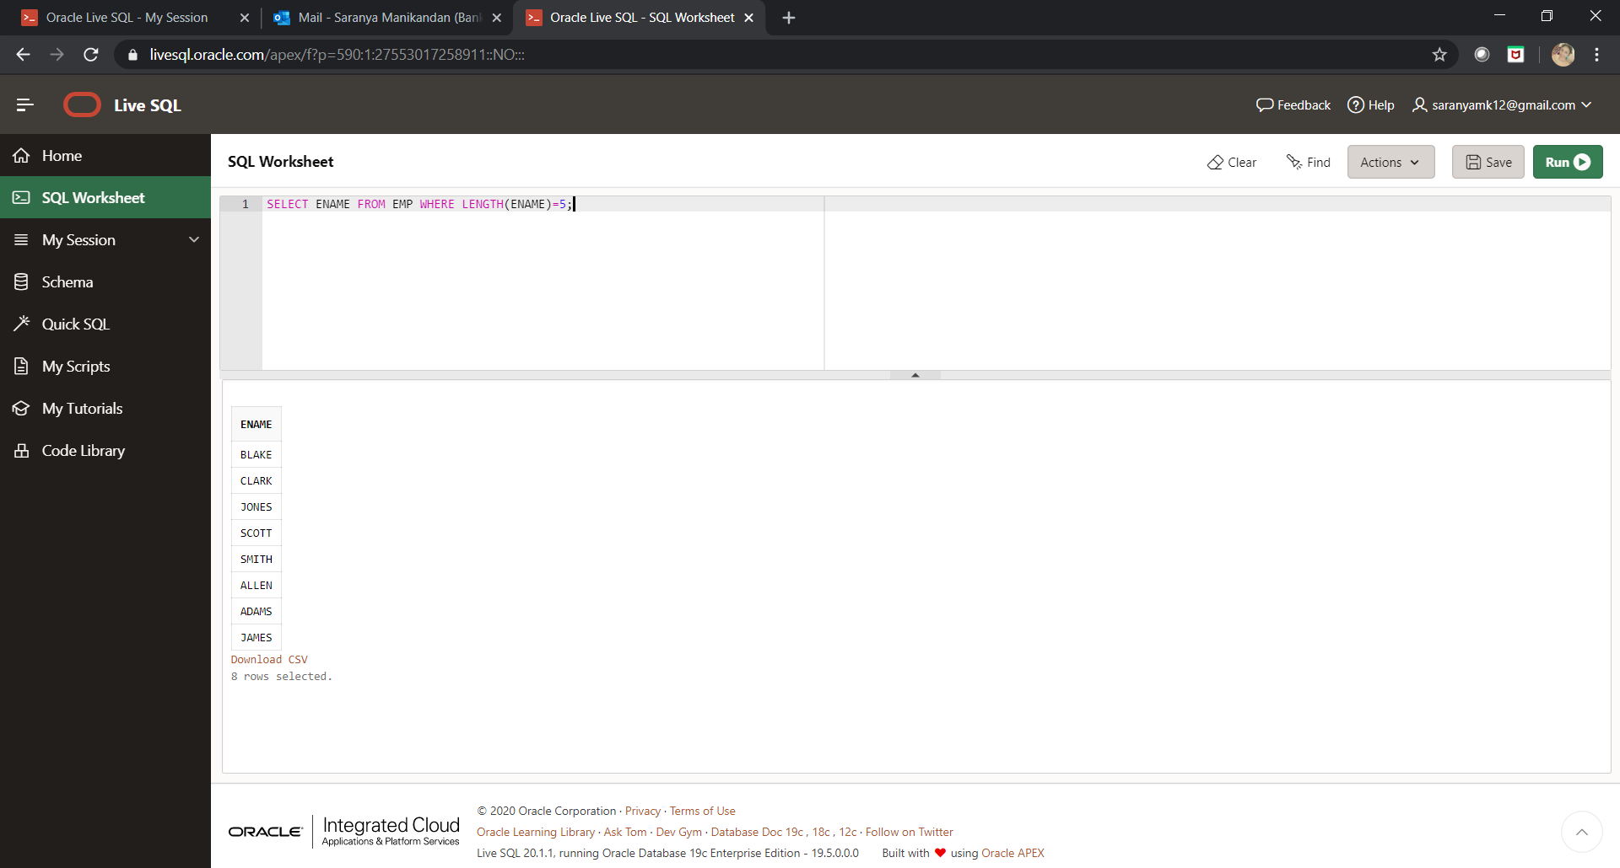

**Q#19:**

SELECT ENAME FROM EMP WHERE LENGTH(ENAME)=5 AND ENAME LIKE 'S%';

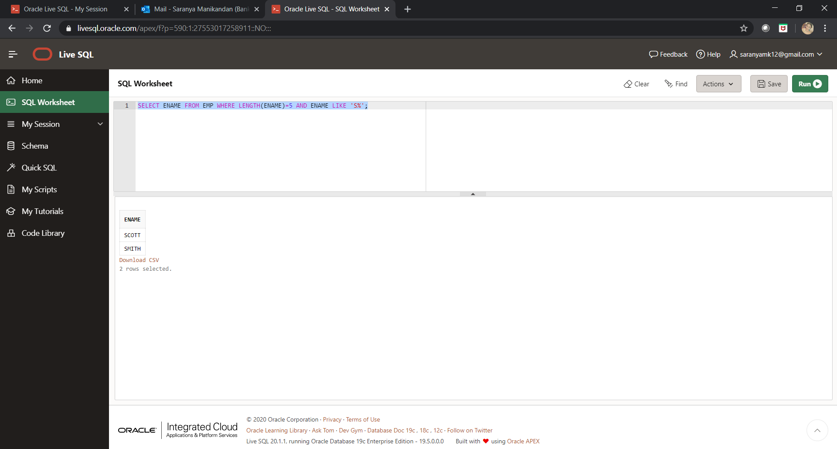

**Q#20:**

SELECT ENAME FROM EMP WHERE LENGTH(ENAME)=4 AND ENAME LIKE'__R%';

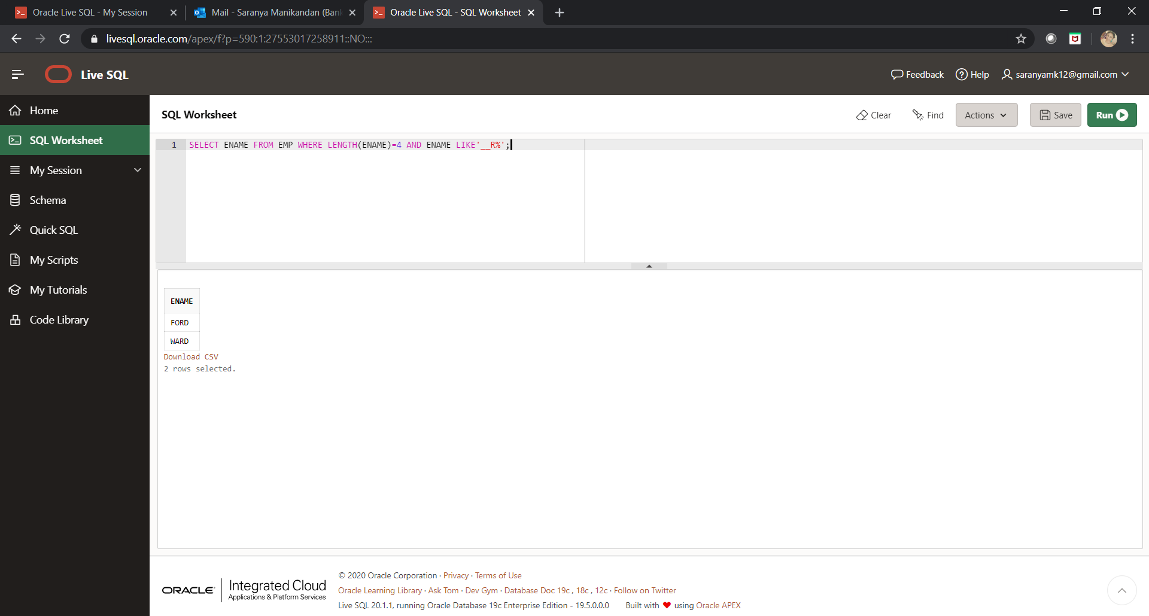

**Q#21:**

SELECT * FROM EMP WHERE EMPNO IN (7369, 7521, 7839, 7934, 7788);

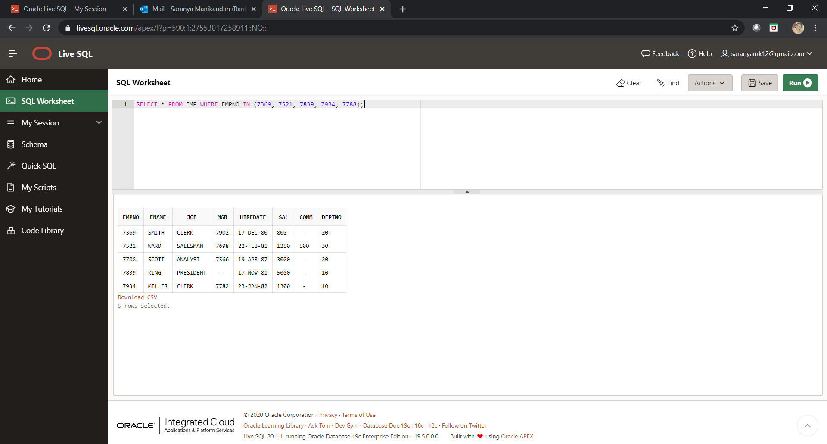

**Q#22:**

SELECT * FROM EMP WHERE DEPTNO NOT IN (10,30,40);

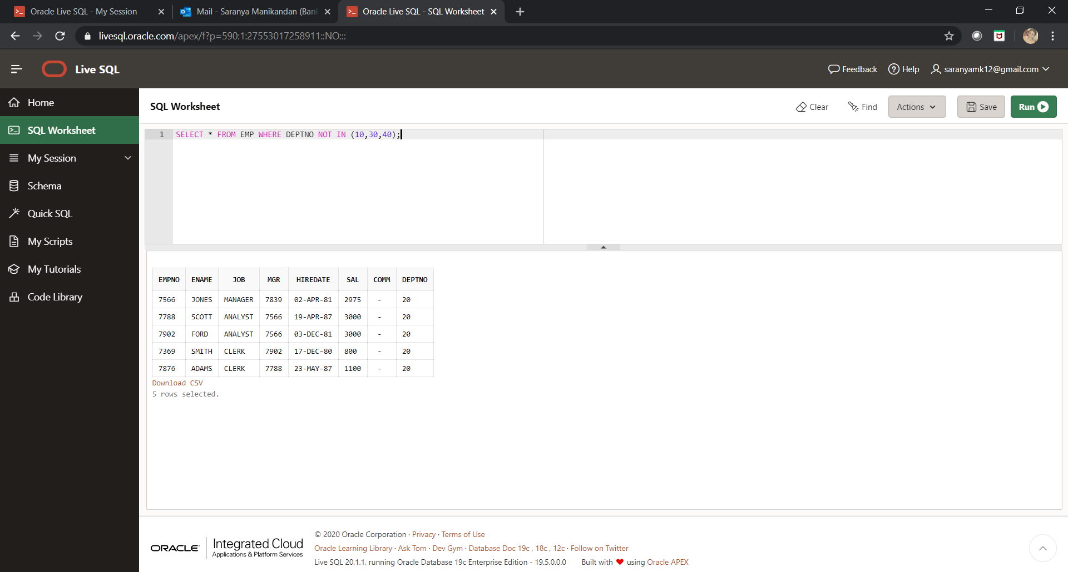

**Q#23:**

SELECT ENAME FROM EMP WHERE HIREDATE BETWEEN '30-JUN-1981' AND '31-DEC-1981';

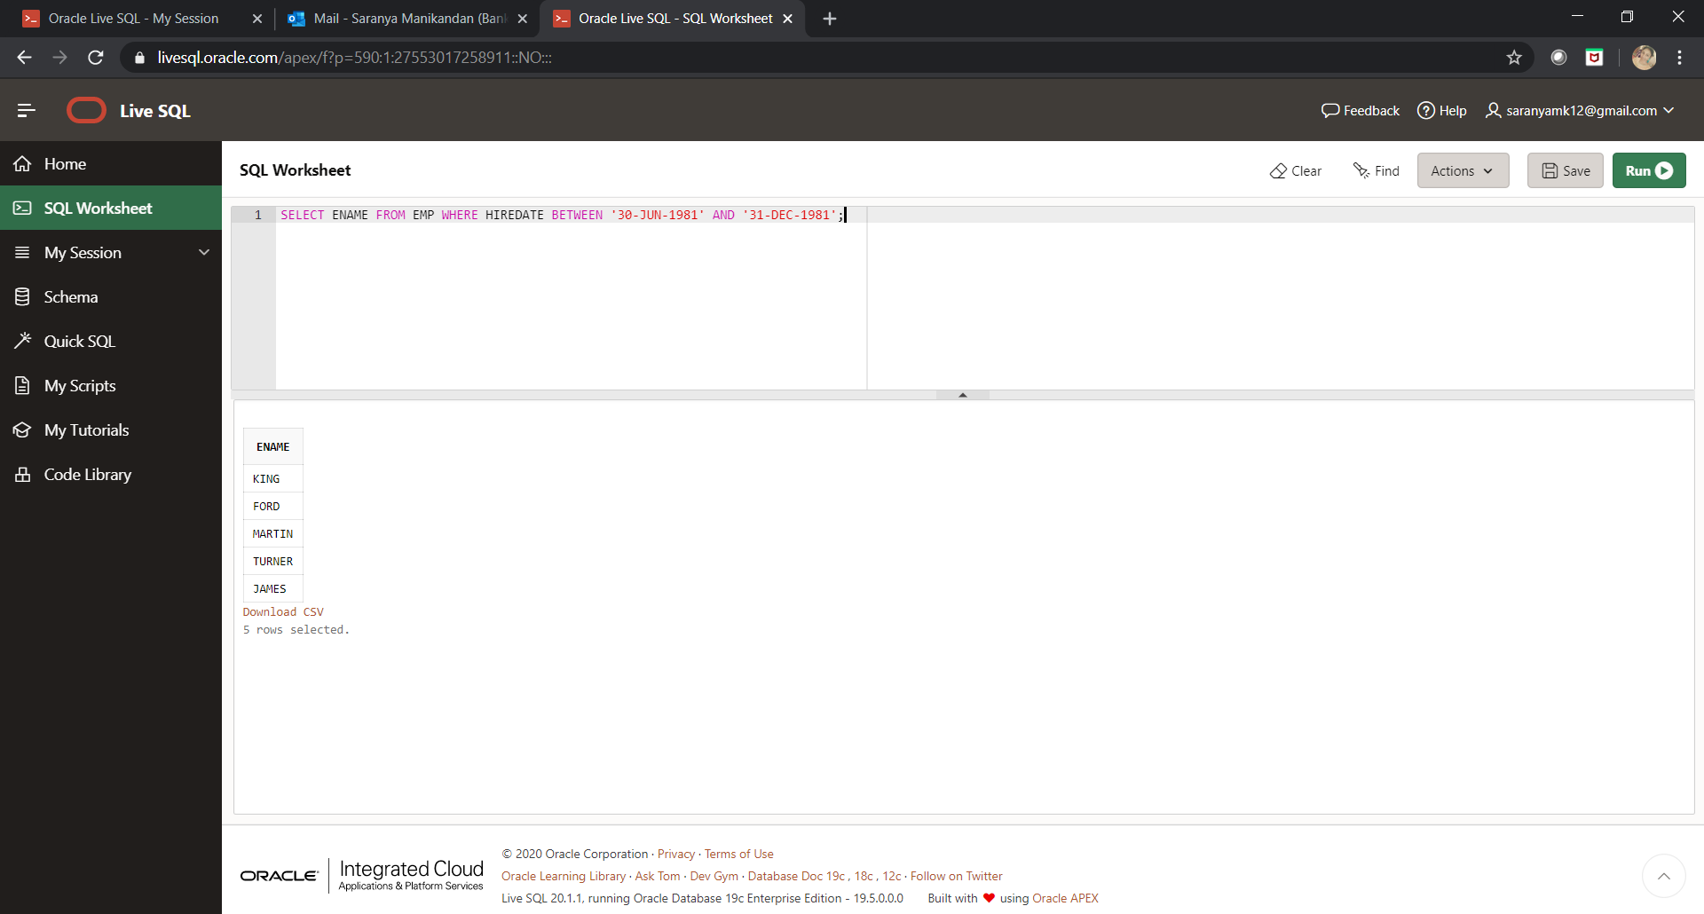

**Q#24:**

SELECT UNIQUE JOB FROM EMP;

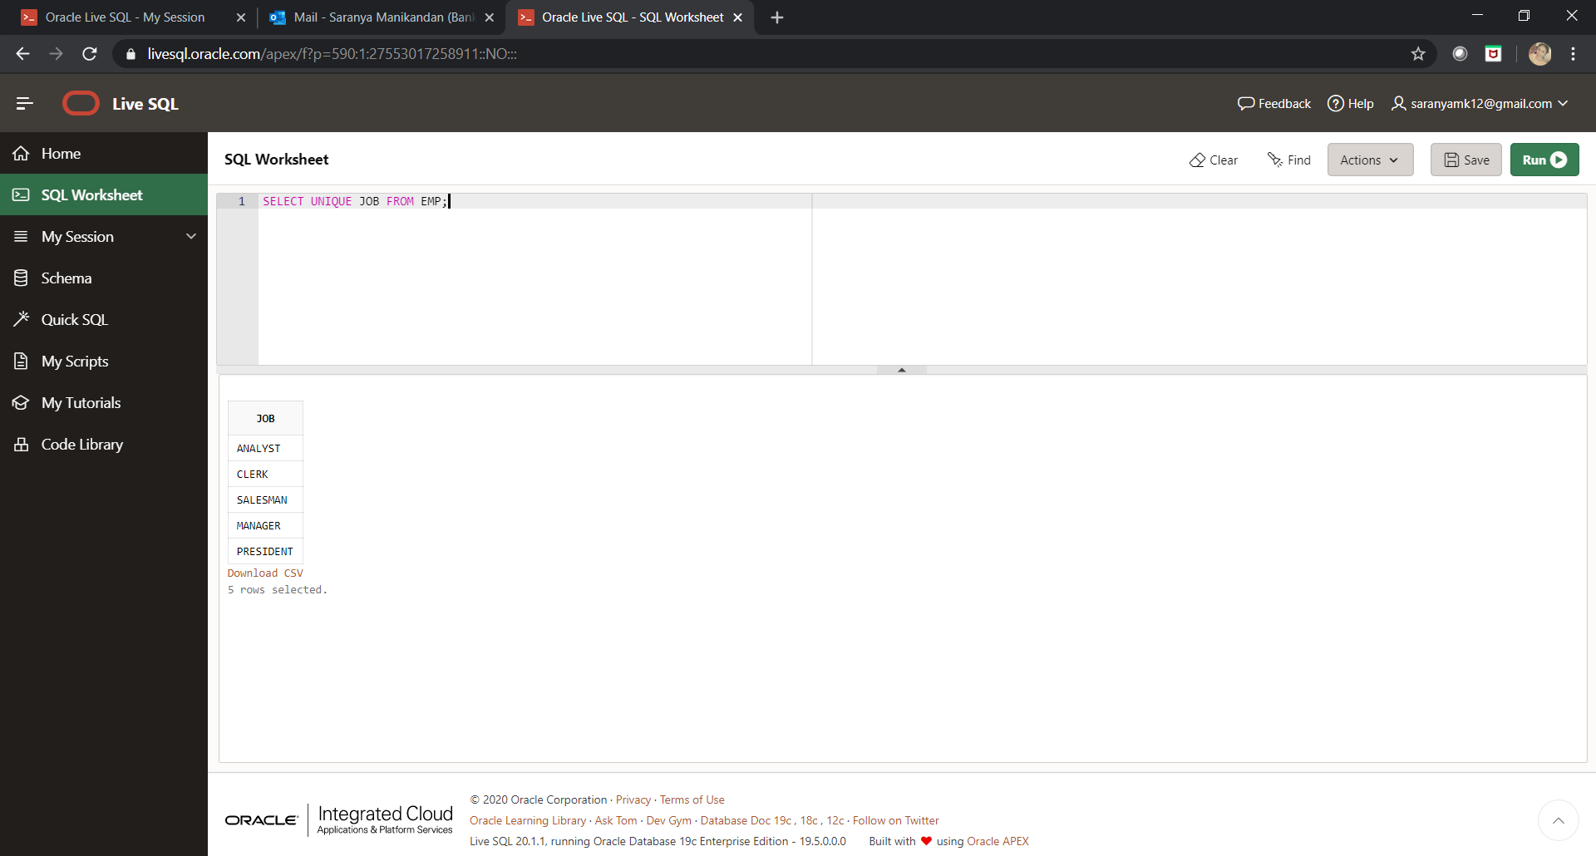

**Q#25:**

SELECT ENAME FROM EMP WHERE COMM IS NULL;

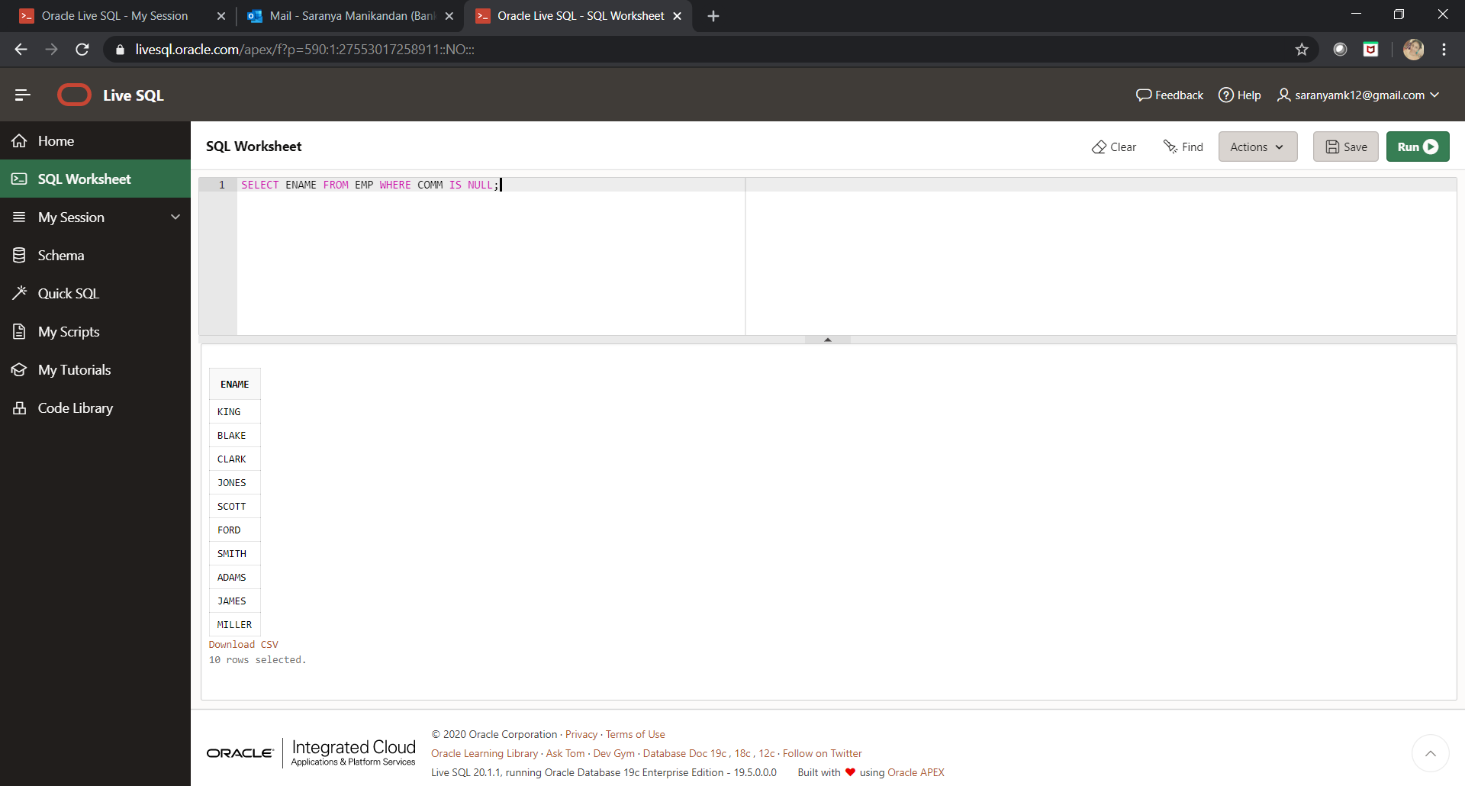

**Q#26:**

SELECT ENAME,JOB FROM EMP WHERE MGR IS NULL;

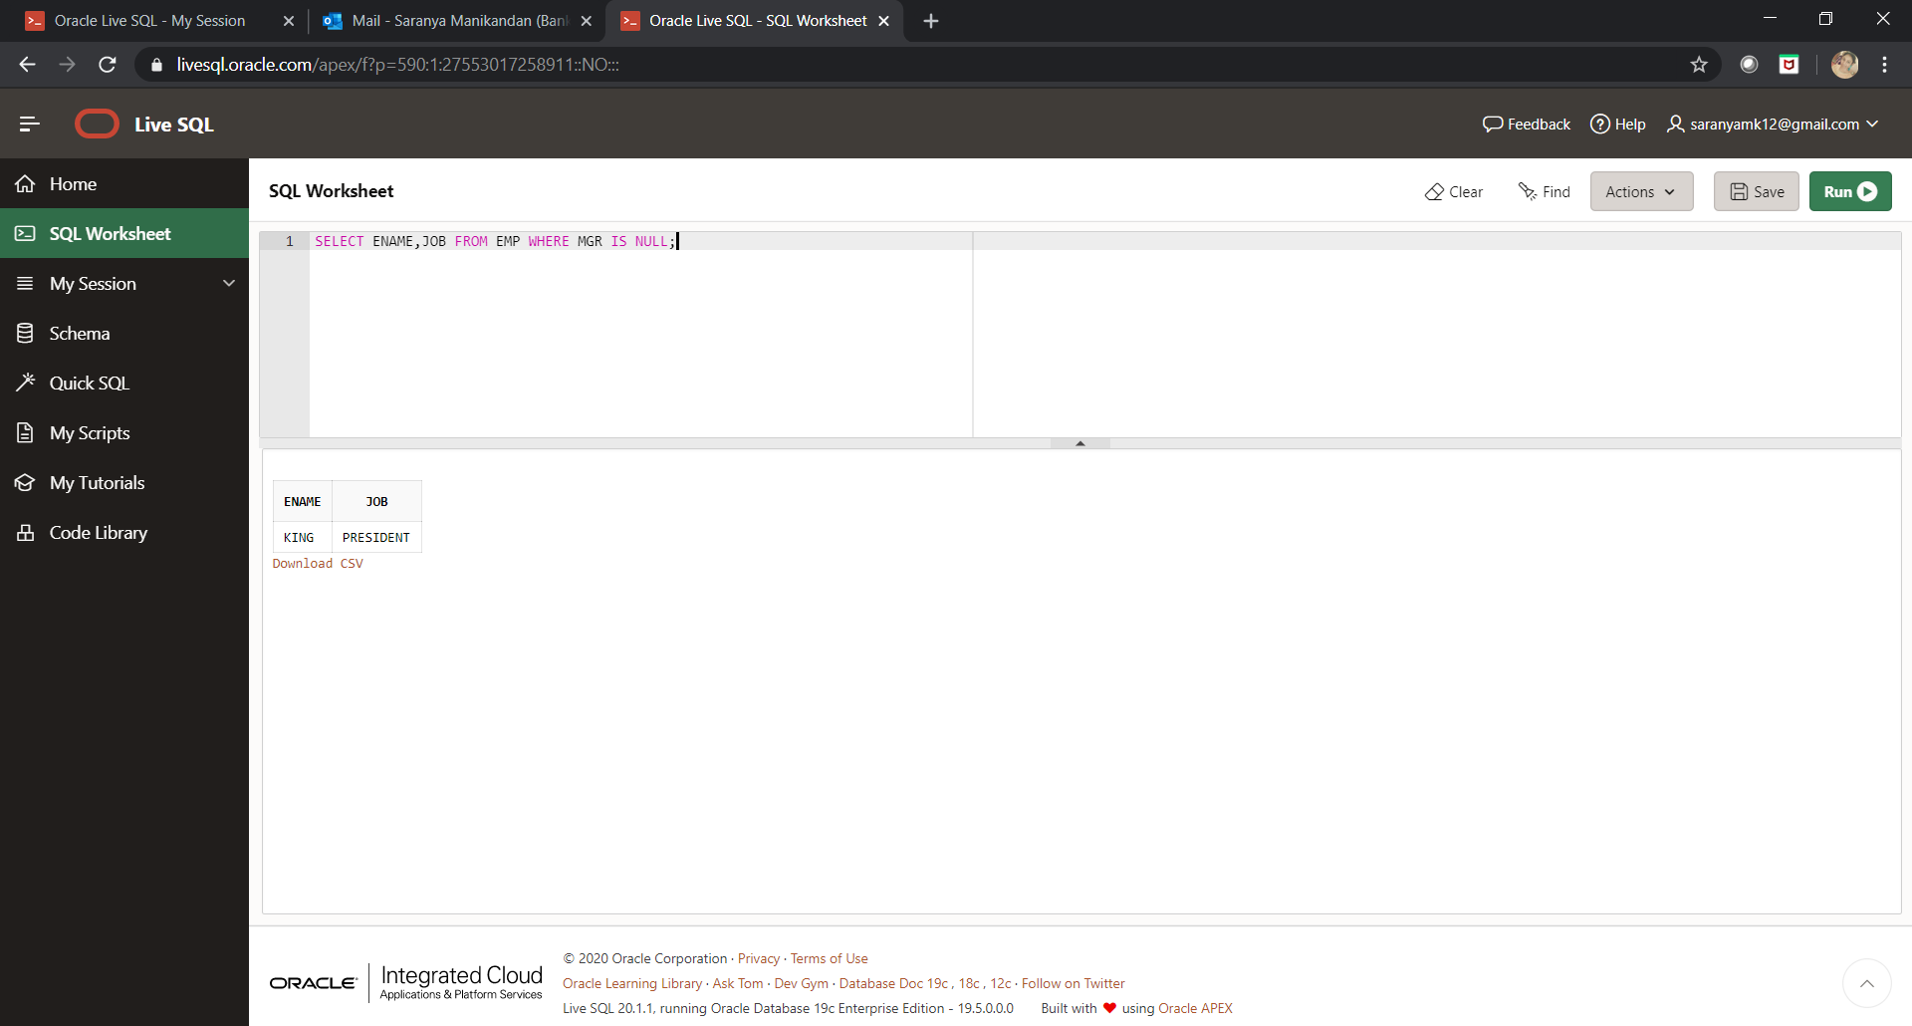

**Q#27:**

SELECT ENAME FROM EMP WHERE COMM IS NOT NULL;

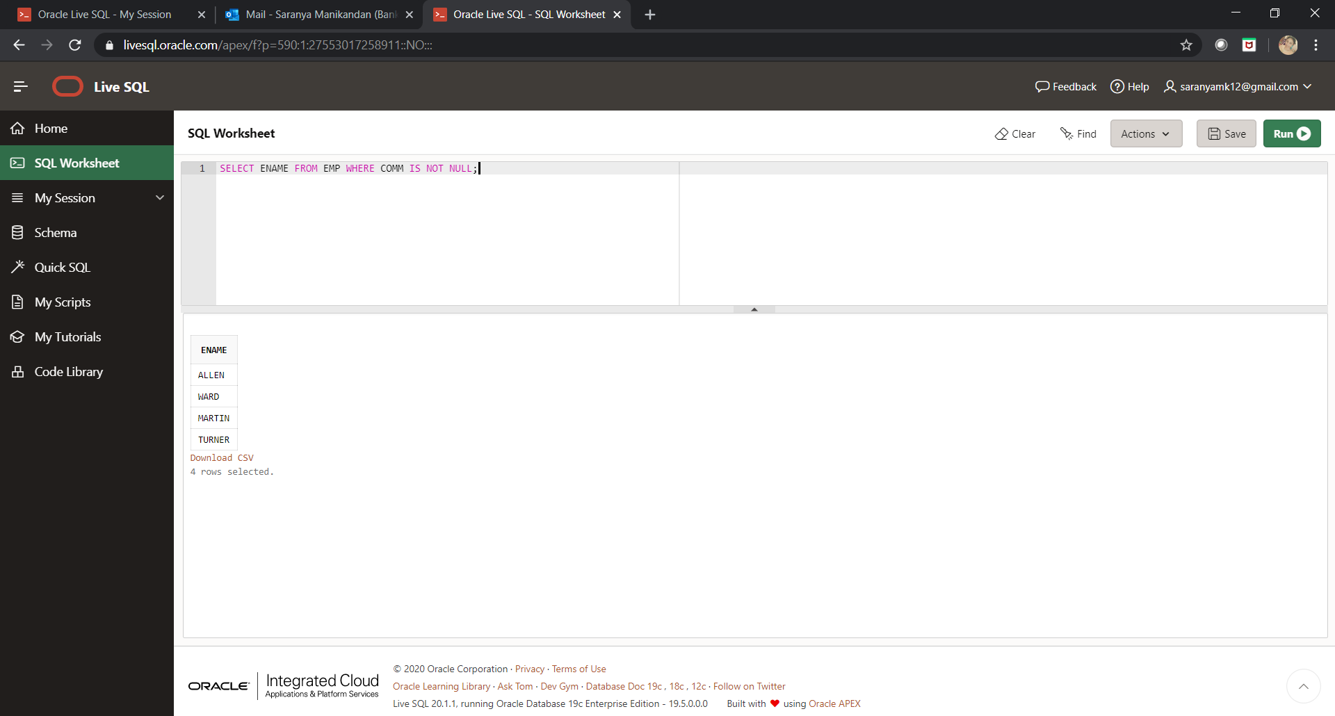

**Q#28:**

SELECT ENAME FROM EMP WHERE ENAME LIKE'_I%';

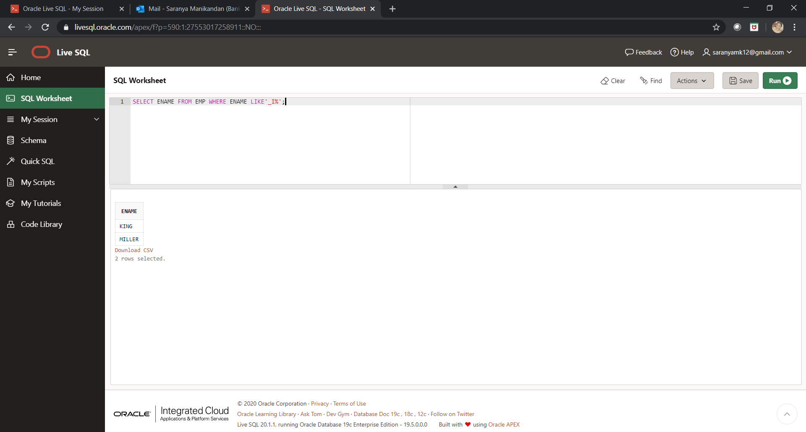

**Q#29:**

SELECT ENAME,SAL,NVL(COMM,0)AS COMM FROM EMP;

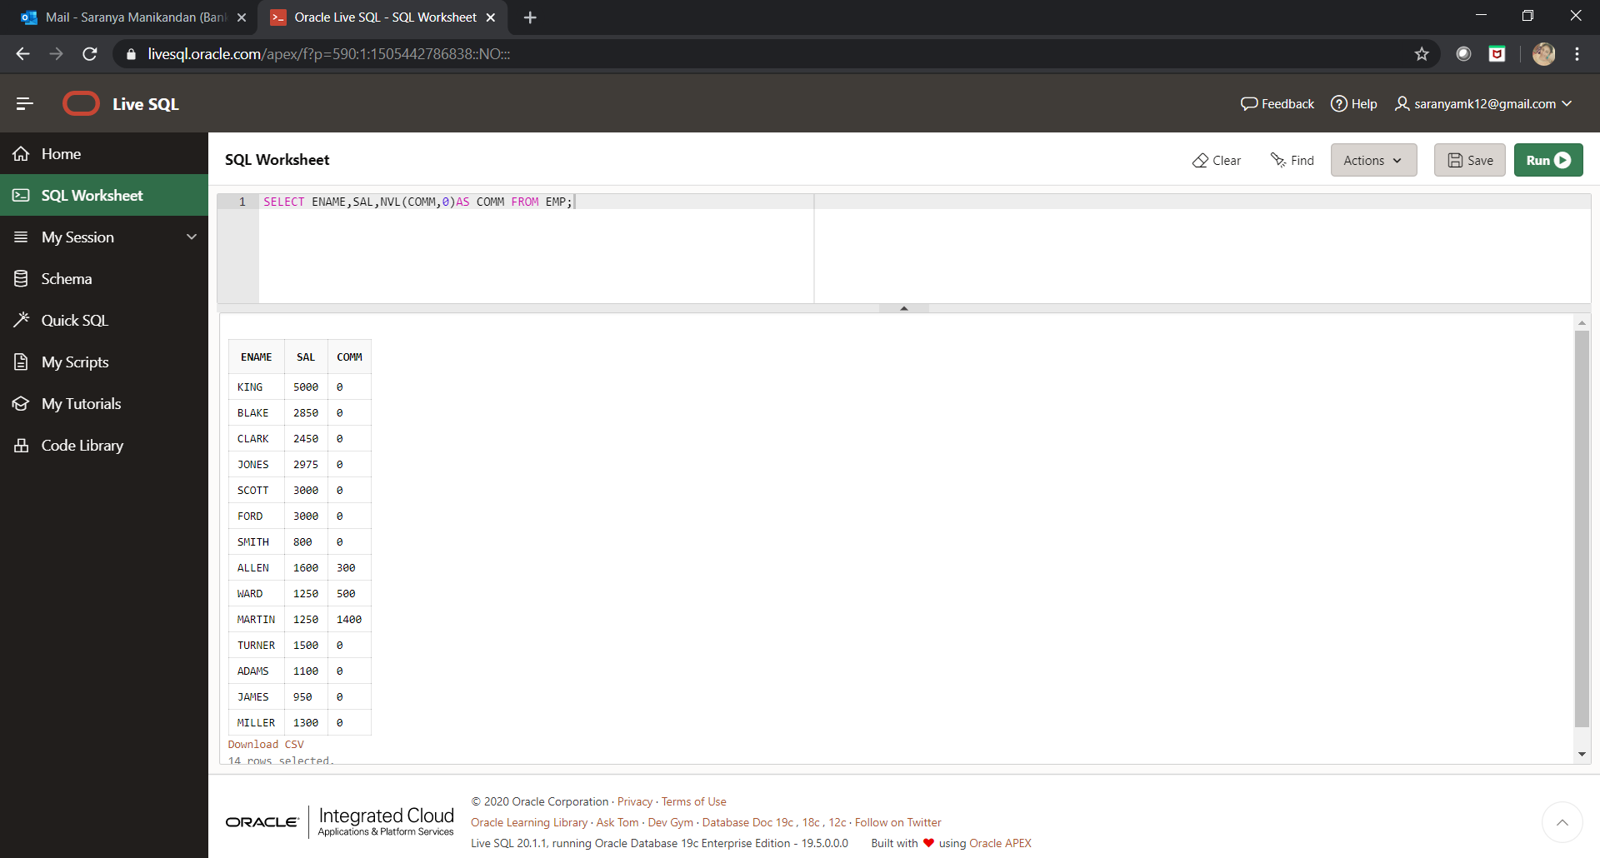

## Round 2 – Group by clause

**Q#1:**

SELECT COUNT(SAL) AS COUNT,AVG(SAL) AS AVERAGE FROM EMP WHERE DEPTNO = 20;

|  |  |
| --- | --- |
| **COUNT** | **AVERAGE** |
| 5 | 2175 |

**Q#2:**

SELECT EMPNO,ENAME,JOB,MGR,HIREDATE,SAL,COMM,DEPTNO FROM EMP WHERE ROUND(MONTHS_BETWEEN(SYSDATE,HIREDATE)/12)>30;

|  |  |  |  |  |  |  |  |
| --- | --- | --- | --- | --- | --- | --- | --- |
| **EMPNO** | **ENAME** | **JOB** | **MGR** | **HIREDATE** | **SAL** | **COMM** | **DEPTNO** |
| 7839 | KING | PRESIDENT | - | 17-NOV-81 | 5000 | - | 10 |
| 7698 | BLAKE | MANAGER | 7839 | 01-MAY-81 | 2850 | - | 30 |
| 7782 | CLARK | MANAGER | 7839 | 09-JUN-81 | 2450 | - | 10 |
| 7566 | JONES | MANAGER | 7839 | 02-APR-81 | 2975 | - | 20 |
| 7788 | SCOTT | ANALYST | 7566 | 19-APR-87 | 3000 | - | 20 |
| 7902 | FORD | ANALYST | 7566 | 03-DEC-81 | 3000 | - | 20 |
| 7369 | SMITH | CLERK | 7902 | 17-DEC-80 | 800 | - | 20 |
| 7499 | ALLEN | SALESMAN | 7698 | 20-FEB-81 | 1600 | 300 | 30 |
| 7521 | WARD | SALESMAN | 7698 | 22-FEB-81 | 1250 | 500 | 30 |
| 7654 | MARTIN | SALESMAN | 7698 | 28-SEP-81 | 1250 | 1400 | 30 |
| 7844 | TURNER | SALESMAN | 7698 | 08-SEP-81 | 1500 | 0 | 30 |
| 7876 | ADAMS | CLERK | 7788 | 23-MAY-87 | 1100 | - | 20 |
| 7900 | JAMES | CLERK | 7698 | 03-DEC-81 | 950 | - | 30 |
| 7934 | MILLER | CLERK | 7782 | 23-JAN-82 | 1300 | - | 10 |

**Q#3:**

SELECT ENAME,HIREDATE FROM EMP ORDER BY HIREDATE DESC;

|  |  |
| --- | --- |
| **ENAME** | **HIREDATE** |
| ADAMS | 23-MAY-87 |
| SCOTT | 19-APR-87 |
| MILLER | 23-JAN-82 |
| FORD | 03-DEC-81 |
| JAMES | 03-DEC-81 |
| KING | 17-NOV-81 |
| MARTIN | 28-SEP-81 |
| TURNER | 08-SEP-81 |
| CLARK | 09-JUN-81 |
| BLAKE | 01-MAY-81 |
| JONES | 02-APR-81 |
| WARD | 22-FEB-81 |
| ALLEN | 20-FEB-81 |
| SMITH | 17-DEC-80 |

**Q#4:**

SELECT ENAME,SAL,SAL*15/100 AS PF,SAL*50/100 AS HRA,SAL*30/100 AS DA,SAL*12 AS GROSS FROM EMP ORDER BY GROSS ASC;

|  |  |  |  |  |  |
| --- | --- | --- | --- | --- | --- |
| **ENAME** | **SAL** | **PF** | **HRA** | **DA** | **GROSS** |
| SMITH | 800 | 120 | 400 | 240 | 9600 |
| JAMES | 950 | 142.5 | 475 | 285 | 11400 |
| ADAMS | 1100 | 165 | 550 | 330 | 13200 |
| MARTIN | 1250 | 187.5 | 625 | 375 | 15000 |
| WARD | 1250 | 187.5 | 625 | 375 | 15000 |
| MILLER | 1300 | 195 | 650 | 390 | 15600 |
| TURNER | 1500 | 225 | 750 | 450 | 18000 |
| ALLEN | 1600 | 240 | 800 | 480 | 19200 |
| CLARK | 2450 | 367.5 | 1225 | 735 | 29400 |
| BLAKE | 2850 | 427.5 | 1425 | 855 | 34200 |
| JONES | 2975 | 446.25 | 1487.5 | 892.5 | 35700 |
| FORD | 3000 | 450 | 1500 | 900 | 36000 |
| SCOTT | 3000 | 450 | 1500 | 900 | 36000 |
| KING | 5000 | 750 | 2500 | 1500 | 60000 |

**Q#5:**

SELECT DEPTNO,COUNT(*) FROM EMP GROUP BY DEPTNO;

|  |  |
| --- | --- |
| **DEPTNO** | **COUNT(*)** |
| 30 | 6 |
| 10 | 3 |
| 20 | 5 |

## Round 3 – SUBQUERIES

**Q#1:**

SELECT * FROM EMP WHERE JOB IN (SELECT JOB FROM EMP WHERE ENAME='SMITH');

|  |  |  |  |  |  |  |  |
| --- | --- | --- | --- | --- | --- | --- | --- |
| **EMPNO** | **ENAME** | **JOB** | **MGR** | **HIREDATE** | **SAL** | **COMM** | **DEPTNO** |
| 7369 | SMITH | CLERK | 7902 | 17-DEC-80 | 800 | - | 20 |
| 7876 | ADAMS | CLERK | 7788 | 23-MAY-87 | 1100 | - | 20 |
| 7900 | JAMES | CLERK | 7698 | 03-DEC-81 | 950 | - | 30 |
| 7934 | MILLER | CLERK | 7782 | 23-JAN-82 | 1300 | - | 10 |

**Q#2:**

SELECT * FROM EMP WHERE HIREDATE > (SELECT HIREDATE FROM EMP WHERE ENAME='ADAMS');

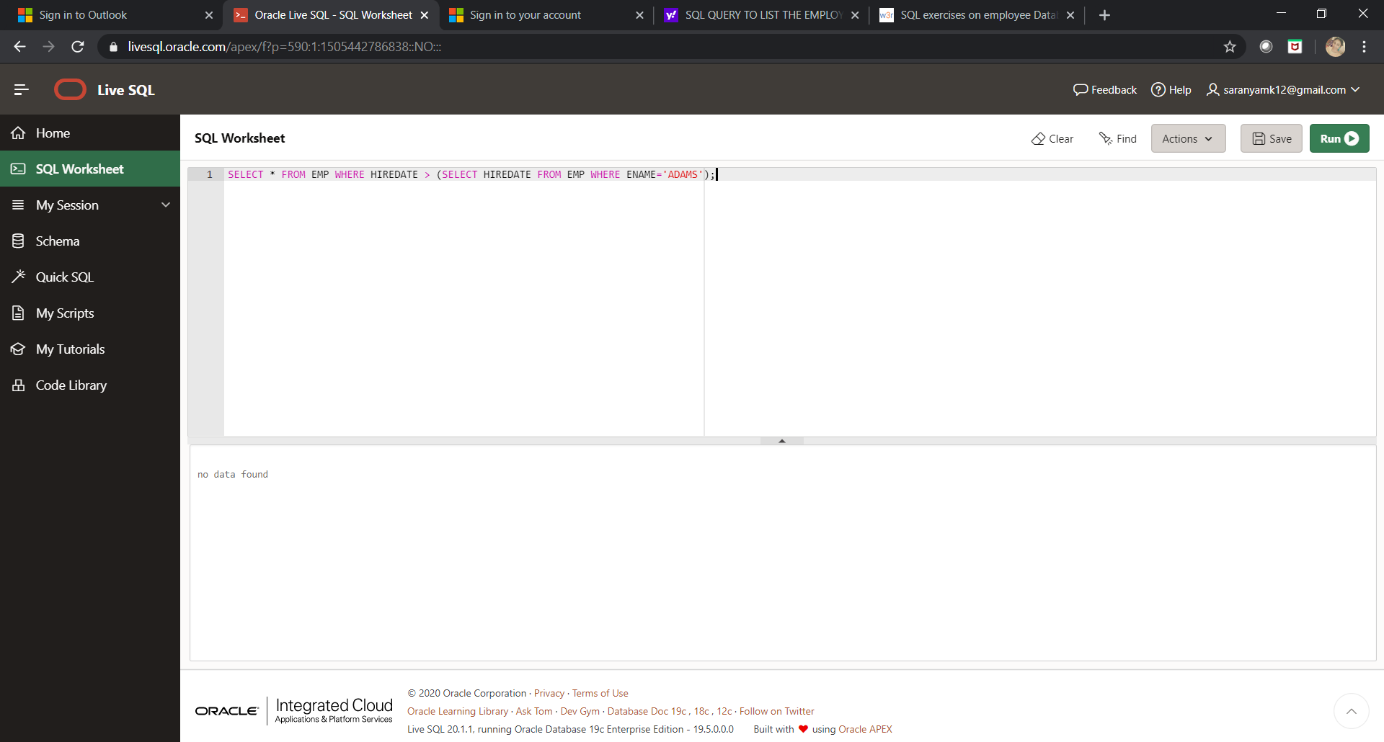

**Q#3:**

SELECT * FROM EMP WHERE SAL > (SELECT SAL FROM EMP WHERE ENAME='SCOTT');

|  |  |  |  |  |  |  |  |
| --- | --- | --- | --- | --- | --- | --- | --- |
| **EMPNO** | **ENAME** | **JOB** | **MGR** | **HIREDATE** | **SAL** | **COMM** | **DEPTNO** |
| 7839 | KING | PRESIDENT | - | 17-NOV-81 | 5000 | - | 10 |

**Q#4:**

SELECT * FROM EMP WHERE SAL IN (SELECT MAX(SAL) FROM EMP);

|  |  |  |  |  |  |  |  |
| --- | --- | --- | --- | --- | --- | --- | --- |
| **EMPNO** | **ENAME** | **JOB** | **MGR** | **HIREDATE** | **SAL** | **COMM** | **DEPTNO** |
| 7839 | KING | PRESIDENT | - | 17-NOV-81 | 5000 | - | 10 |

**Q#5:**

SELECT * FROM EMP WHERE SAL > (SELECT MAX(SAL) FROM EMP WHERE DEPTNO='30');

|  |  |  |  |  |  |  |  |
| --- | --- | --- | --- | --- | --- | --- | --- |
| **EMPNO** | **ENAME** | **JOB** | **MGR** | **HIREDATE** | **SAL** | **COMM** | **DEPTNO** |
| 7839 | KING | PRESIDENT | - | 17-NOV-81 | 5000 | - | 10 |
| 7566 | JONES | MANAGER | 7839 | 02-APR-81 | 2975 | - | 20 |
| 7788 | SCOTT | ANALYST | 7566 | 19-APR-87 | 3000 | - | 20 |
| 7902 | FORD | ANALYST | 7566 | 03-DEC-81 | 3000 | - | 20 |

## Round 4 – Joins (Mortal mode)

**Q#1:**

SELECT E.EMPNO,E.ENAME,E.DEPTNO,D.DNAME FROM EMP E,DEPT D WHERE E.DEPTNO=D.DEPTNO;

|  |  |  |  |
| --- | --- | --- | --- |
| **EMPNO** | **ENAME** | **DEPTNO** | **DNAME** |
| 7839 | KING | 10 | ACCOUNTING |
| 7698 | BLAKE | 30 | SALES |
| 7782 | CLARK | 10 | ACCOUNTING |
| 7566 | JONES | 20 | RESEARCH |
| 7788 | SCOTT | 20 | RESEARCH |
| 7902 | FORD | 20 | RESEARCH |
| 7369 | SMITH | 20 | RESEARCH |
| 7499 | ALLEN | 30 | SALES |
| 7521 | WARD | 30 | SALES |
| 7654 | MARTIN | 30 | SALES |
| 7844 | TURNER | 30 | SALES |
| 7876 | ADAMS | 20 | RESEARCH |
| 7900 | JAMES | 30 | SALES |
| 7934 | MILLER | 10 | ACCOUNTING |

**Q#2:**

SELECT ENAME,MGR FROM EMP;

|  |  |
| --- | --- |
| **ENAME** | **MGR** |
| KING | - |
| BLAKE | 7839 |
| CLARK | 7839 |
| JONES | 7839 |
| SCOTT | 7566 |
| FORD | 7566 |
| SMITH | 7902 |
| ALLEN | 7698 |
| WARD | 7698 |
| MARTIN | 7698 |
| TURNER | 7698 |
| ADAMS | 7788 |
| JAMES | 7698 |
| MILLER | 7782 |

**Q#3:**

SELECT E.EMPNO,E.ENAME,E.JOB,E.MGR,E.SAL,E.COMM,D.DEPTNO FROM EMP E,DEPT D WHERE D.DNAME='RESEARCH' AND E.DEPTNO=D.DEPTNO;

|  |  |  |  |  |  |  |
| --- | --- | --- | --- | --- | --- | --- |
| **EMPNO** | **ENAME** | **JOB** | **MGR** | **SAL** | **COMM** | **DEPTNO** |
| 7566 | JONES | MANAGER | 7839 | 2975 | - | 20 |
| 7788 | SCOTT | ANALYST | 7566 | 3000 | - | 20 |
| 7902 | FORD | ANALYST | 7566 | 3000 | - | 20 |
| 7369 | SMITH | CLERK | 7902 | 800 | - | 20 |
| 7876 | ADAMS | CLERK | 7788 | 1100 | - | 20 |

**Q#4:**

SELECT * FROM EMP E LEFT OUTER JOIN DEPT D ON E.DEPTNO=D.DEPTNO;

|  |  |  |  |  |  |  |  |  |  |  |
| --- | --- | --- | --- | --- | --- | --- | --- | --- | --- | --- |
| **EMPNO** | **ENAME** | **JOB** | **MGR** | **HIREDATE** | **SAL** | **COMM** | **DEPTNO** | **DEPTNO** | **DNAME** | **LOC** |
| 7839 | KING | PRESIDENT | - | 17-NOV-81 | 5000 | - | 10 | 10 | ACCOUNTING | NEW YORK |
| 7782 | CLARK | MANAGER | 7839 | 09-JUN-81 | 2450 | - | 10 | 10 | ACCOUNTING | NEW YORK |
| 7934 | MILLER | CLERK | 7782 | 23-JAN-82 | 1300 | - | 10 | 10 | ACCOUNTING | NEW YORK |
| 7566 | JONES | MANAGER | 7839 | 02-APR-81 | 2975 | - | 20 | 20 | RESEARCH | DALLAS |
| 7788 | SCOTT | ANALYST | 7566 | 19-APR-87 | 3000 | - | 20 | 20 | RESEARCH | DALLAS |
| 7902 | FORD | ANALYST | 7566 | 03-DEC-81 | 3000 | - | 20 | 20 | RESEARCH | DALLAS |
| 7369 | SMITH | CLERK | 7902 | 17-DEC-80 | 800 | - | 20 | 20 | RESEARCH | DALLAS |
| 7876 | ADAMS | CLERK | 7788 | 23-MAY-87 | 1100 | - | 20 | 20 | RESEARCH | DALLAS |
| 7698 | BLAKE | MANAGER | 7839 | 01-MAY-81 | 2850 | - | 30 | 30 | SALES | CHICAGO |
| 7499 | ALLEN | SALESMAN | 7698 | 20-FEB-81 | 1600 | 300 | 30 | 30 | SALES | CHICAGO |
| 7521 | WARD | SALESMAN | 7698 | 22-FEB-81 | 1250 | 500 | 30 | 30 | SALES | CHICAGO |
| 7654 | MARTIN | SALESMAN | 7698 | 28-SEP-81 | 1250 | 1400 | 30 | 30 | SALES | CHICAGO |
| 7844 | TURNER | SALESMAN | 7698 | 08-SEP-81 | 1500 | 0 | 30 | 30 | SALES | CHICAGO |
| 7900 | JAMES | CLERK | 7698 | 03-DEC-81 | 950 | - | 30 | 30 | SALES | CHICAGO |